**Instructions to run**

**R installation and setup:**

1. Download R executable from <http://cran.us.r-project.org/>.
2. Install R. Leave all default settings in the installation options.
3. Installing the Packages (libraries) required.

Click on the R executable -> create a new .R script

(File -> New File -> R Script) and run the below commands.

install.packages (dplyr)

install.packages (queueing)

install.packages (plyr)

install.packages (lubridate)

1. Unzip the <zip name?>.zip into a directory of preference.
2. Update the R scripts with the unzipped directory location appropriately in all the scripts (1. 2. ).

example: etwd("C:\\Work\\BIG_DATA\\BankOfBaroda\\BoB_hackathon_workspace\\R_DT_Recommend")

1. Relative folder Structure on top of the unzipped directory location

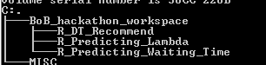

1. Click on the R runtime icon and open the .R script ( File -> Open Script-> Navigate to the location of R file )
2. Select All and Hit Enter to execute. To see the working of the Individual Script

R_Predicting_Lambda folder contains the code for predicting arrival rate

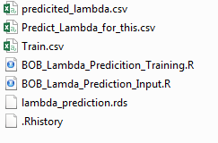

BOB_Lambda_Predicition_Training.R contains the code that take Train.csv as input and creates model lambda_prediction.rds

*BOB_Lambda_Predicition_Input.R* contains the code that refers the model created by the *BOB_Lambda_Predicition_Training.R script* and predicts the number of customers arrivals for the list of the ATMs specified in *Predict_Lambda_for_this.csv*

*R_Predicting_Waiting_Time* folder contains the code for predicting waiting time.

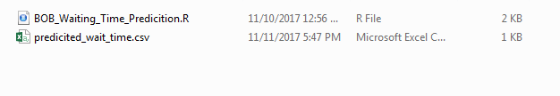

*BOB_Waiting_Time_Predicition.R* contains the code that predicts the waiting time from the ATMs in the Predict_Lambda_for_this.csv

R_DT_Recommend folder contains code that recommends the ATMs

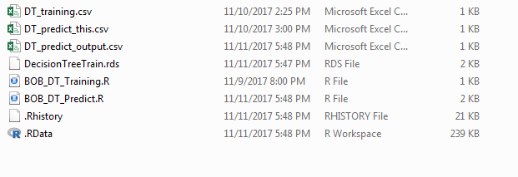

*BOB_DT_Training.R* contains the code that create the Model for recommending the ATM. *DT_Training.csv* is used to train and create this model.

*BOB_DT_Predict.R* contains the code that recommends ATMs from the list of the ATMs in the *DT_Predict this.csv*

*NOTE : change the path “C:\\Work\\BIG_DATA\\BankOfBaroda” in all the R script with the unzipped location*

**Node.js installation and ‘ATM Recommender’ service setup:**

* Install node.js version 6+ onwards from the website <https://nodejs.org/en>
* Copy “ATMRecommendor” in any drive.
* Open command prompt and go to the “ATMRecommendor” directory
* Run command “node index.js”
* C:\ATMRecommendor>node index.js
* Once you run node.js application, it will give a message (“App listening on port 8082”) on command prompt ;